Sticky Tape Activity Lab Worksheet Name: ___________________________________

Summary Page

|  |  |
| --- | --- |
| #5: Sketch with labeled force vectors for two top tapes close enough to affect each other. | Sketch with labeled force vectors for two top tapes half as far apart as left sketch |
| #8: Describe paper on paper interaction | #9: Describe foil on foil interaction |
| #13: Describe top tape and foil interaction          Diagram with forces | Describe top tape and paper interaction          Diagram with forces |

Thought pages:

1. Imagine you could see the differences between the top and bottom tapes at the atomic level. On the partially separated T and B tapes invent a way of representing how the tapes change as they are separated.

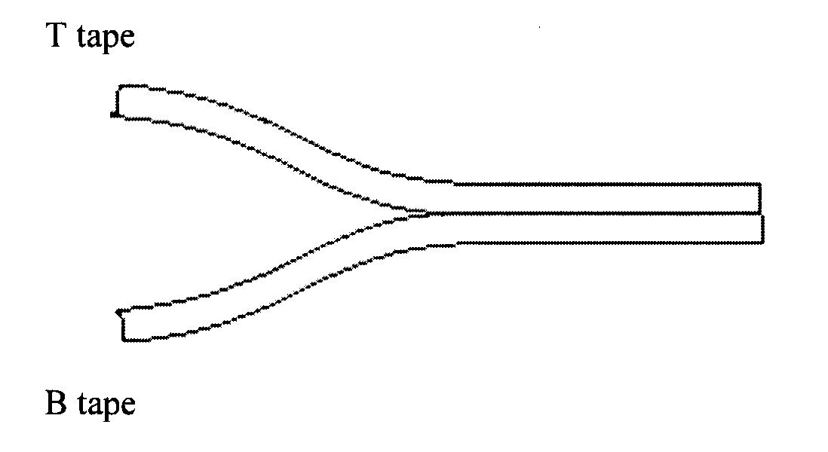

1. Invent a way for the paper to be attracted to both a top and a bottom tape while keeping these facts in mind. The paper is neutral and electrons can’t move away from the nucleus

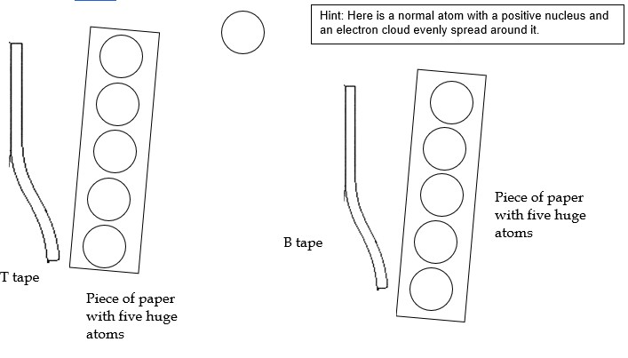

1. Invent a way for the foil to be attracted to both a top and a bottom tape while keeping these facts in mind. The foil is neutral and each atom has a free electron that can move around

